
Patuakhali Science and Technology University
Faculty of Computer Science and Engineering

CCE 322 ::: Computer Peripheral and Interfacing Sessional
Sessional Project Proposal

Project Title : "AI-Based Smart Agriculture Decision Support System with Smart Irrigation and Plant Disease Detection using Raspberry Pi"

Submission Date : 22-01-2026

Submitted from,  ID: Name:  2102031 TANVIR ANJUM RAHAT 2102040 MAHIR ASHAB  2102071 JIHADUL ISLAM  2102079 TANMOY KUMAR DAS  2102078 HRIVU SAMADDAR | Submitted to,  - Prof. Dr. Md Samsuzzaman  Professor,  Department of Computer and Communication Engineering,  Patuakhali Science and Technology University.  - Sarna Majumder  Associate Professor,  Department of Computer and Communication Engineering,  Patuakhali Science and Technology University.

Table of Contents
- Project Title
- Abstract
- Problem Statement
- Objectives
- Scope of the Project
- System Overview
- Hardware Components and Sensor Details
  - 7.1 Core Controller
  - 7.2 Soil Sensors
  - 7.3 Weather Sensors
  - 7.4 Imaging & Actuators
- Software and Technology Stack
  - 8.1 Programming & Backend
  - 8.2 Machine Learning & Deep Learning
  - 8.3 Database & Frontend
- Machine Learning & AI Methodology
  - 9.1 Crop & Rice Recommendation
  - 9.2 Plant Disease Detection
  - 9.3 Treatment Recommendation
- Smart Irrigation System Design
- System Workflow
- Dataset Sources
- Expected Outcomes
- Future Enhancements
- Project Timeline
- Conclusion
- Estimated Equipment Cost
- Team Members & Roles
- Price picture of all sensors
- Sensor Price link

AI-Based Smart Agriculture Decision Support System

Using Raspberry Pi, IoT, Machine Learning & Computer Vision

1. Project Title
AI-Based Smart Agriculture Decision Support System with Smart Irrigation and Plant Disease Detection using Raspberry Pi

2. Abstract
Agriculture is the backbone of Bangladesh’s economy, yet traditional farming practices often rely on experience rather than data-driven decision-making. This project proposes an AI-powered Smart Agriculture System that integrates IoT sensors, Machine Learning (ML), Deep Learning (DL), and automation using a Raspberry Pi. The system collects real-time soil and weather data, recommends suitable crops and rice varieties, detects plant diseases from leaf images, suggests treatments, and automatically controls irrigation. The proposed solution aims to increase crop yield, reduce water and fertilizer wastage, and support farmers with intelligent, real-time decisions.

3. Problem Statement
Farmers face multiple challenges such as:
- Uncertainty about which crop or rice variety to cultivate
- Overuse or underuse of water and fertilizers
- Late detection of plant diseases
- Dependency on manual monitoring
These issues lead to reduced yield, increased cost, and environmental damage. There is a strong need for a smart, automated, and AI-driven agricultural decision support system.

4. Objectives
The main objectives of this project are:
- To monitor soil and environmental conditions using sensors
- To recommend suitable crops and rice varieties using ML
- To detect plant diseases from leaf images using Deep Learning
- To suggest appropriate treatment and fertilizer plans
- To design an automated smart irrigation system
- To provide a user-friendly dashboard for farmers

5. Scope of the Project
- Suitable for rice-based agriculture in Bangladesh
- Can be extended to vegetables and other crops
- Supports small to medium-scale farms
- Works in both online and offline environments

6. System Overview
The system consists of four major subsystems:
- Soil & Weather Monitoring System
- AI-Based Crop & Rice Recommendation System
- Plant Disease Detection & Treatment System
- Smart Irrigation Control System

7. Hardware Components and Sensor Details

7.1 Core Controller
- Raspberry Pi 4/5: Central processing and control unit
- Micro SD Card: Operating system and data storage

7.2 Soil Sensors
- Soil NPK Sensor: Measures Nitrogen, Phosphorus, Potassium levels
- Soil pH Sensor: Determines soil acidity or alkalinity
- Soil Moisture Sensor: Measures soil water content
- EC Sensor (Optional): Measures soil salinity

7.3 Weather Sensors
- DHT22 / BME280: Temperature and humidity measurement
- Rain Sensor: Detects rainfall to control irrigation

7.4 Imaging & Actuators
- Raspberry Pi Camera Module: Captures leaf images for disease detection
- Relay Module: Controls irrigation pump
- Water Pump / Solenoid Valve: Automated irrigation

8. Software and Technology Stack

8.1 Programming & Backend
- Python
- Flask / FastAPI
- REST API

8.2 Machine Learning & Deep Learning
- Scikit-learn (Crop & Rice Recommendation)
- TensorFlow / PyTorch (CNN-based Disease Detection)

8.3 Database & Frontend
- MySQL / SQLite
- HTML, CSS, JavaScript
- Web Dashboard with charts and alerts

9. Machine Learning & AI Methodology

9.1 Crop & Rice Recommendation
Input Parameters:
- N, P, K
- Soil pH
- Soil Moisture
- Temperature
- Humidity
- Rainfall
Algorithms Used:
- Decision Tree
- Random Forest
- XGBoost
Output:
- Best crop suggestion
- Best rice variety (BRRI dhan)
- Fertilizer recommendation

9.2 Plant Disease Detection
- Image input from leaf
- CNN / Transfer Learning (MobileNet / ResNet)
- Output: Disease name and severity

9.3 Treatment Recommendation
- Rule-based + AI logic
- Suggests pesticide, dosage, and application method

10. Smart Irrigation System Design
- Soil moisture-based irrigation control
- Crop-specific water requirement
- Rain-aware irrigation stop
- Automatic ON/OFF using relay
Logic:
If soil moisture < threshold AND no rain → Pump ON
Else → Pump OFF

11. System Workflow
- Sensors collect real-time data
- Raspberry Pi processes data
- ML/DL models analyze data
- Decisions are generated (crop, disease, irrigation)
- Results displayed on dashboard
- Irrigation system operates automatically

12. Dataset Sources
- Kaggle Crop Recommendation Dataset
- PlantVillage & Rice Leaf Disease Dataset
- FAO & BRRI reports
- Real-time sensor data (own dataset)

13. Expected Outcomes
- Increased crop yield
- Reduced water and fertilizer wastage
- Early disease detection
- Smart decision support for farmers
- Practical implementation of AI & IoT

14. Future Enhancements
- Mobile app with Bangla voice assistant
- Weather forecast integration
- Drone and satellite (NDVI) data
- Federated learning for privacy

15. Project Timeline (4 Months)
- Month 1: Literature review, hardware setup
- Month 2: Sensor integration & data collection
- Month 3: ML & DL model development
- Month 4: Dashboard, testing & documentation

16. Conclusion
This project presents a complete, intelligent, and automated agricultural solution using Raspberry Pi, IoT, Machine Learning, and Computer Vision. It addresses real-world farming challenges and has strong potential for academic research, real deployment, and future commercialization.

17. Estimated Equipment Cost (Price picture is on last page)
Sl | Equipment / Sensor | Quantity | Approx. Unit Price (BDT) | Total
1 | Raspberry Pi 5 (4GB) | 1 | 19700 | 19700
2 | Soil NPK Sensor | 1 | 15199 | 15199
3 | Raspberry Pi Camera Module | 1 | 6880 | 6880
4 | Micro SD Card (32GB) | 1 | 950 | 950
5 | Soil pH Sensor | 1 | 2,000 | 2,000
6 | Soil Moisture Sensor | 1 | 189 | 189
7 | DHT22 Sensor | 1 | 260 | 260
8 | Rain Sensor | 1 | 80 | 80
9 | Power Supply & Casing | 1 | 1450+500 | 1950
10 | Relay Module (4 Channel) | 1 | 298 | 298
11 | Water Pump / Solenoid Valve | 1 | 150 | 150
12 | Jumper Wires, Breadboard | 1 set | 160+145 | 305
 | Estimated Total Cost |  |  | 47,961 BDT (approx.)

18. Team Members & Roles
Student ID | Name | Responsibility
2102031 | Tanvir Anjum Rahat | IoT Hardware Integration & Sensor Calibration
2102040 | Mahir Ashab | Machine Learning Model (Crop & Yield Prediction)
2102071 | Jihadul Islam | System Design, Backend & Documentation
2102079 | Tanmoy Kumar Das | Deep Learning (Leaf Disease Detection – CNN)
2102078 | Hrivu Samaddar | Frontend Dashboard & Data Visualization
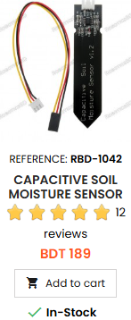
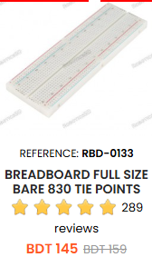
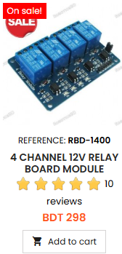
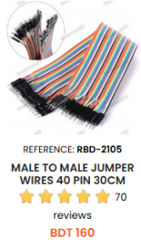
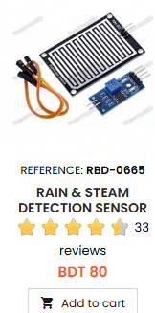
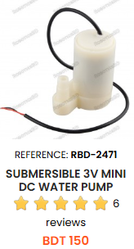
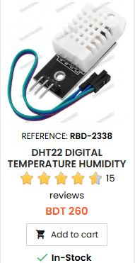
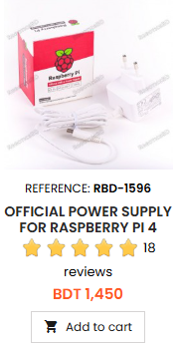
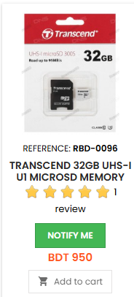
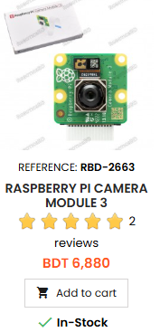
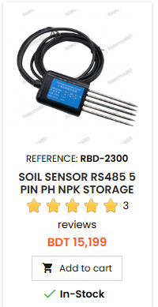
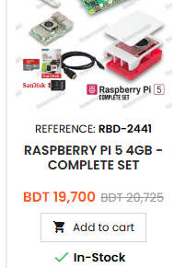

Raspberry pi 5 (4gb) = https://store.roboticsbd.com/raspberry-pi/2441-raspberry-pi-5-4gb-complete-set-robotics-bangladesh.html

NPK sensor = https://store.roboticsbd.com/soil-waterph/2300-soil-sensor-rs485-5-pin-ph-npk-temperature-and-humidity-ec-sensor-conductivity-tester-multi-parameter-robotics-bangladesh.html

Power supply for pi = https://store.roboticsbd.com/raspberry-pi/1596-official-power-supply-for-raspberry-pi-4-white-robotics-bangladesh.html

Breadboard = https://store.roboticsbd.com/components/133-breadboard-full-size-bare-830-tie-points-robotics-bangladesh.html

Jumper wires = https://store.roboticsbd.com/connector/2105-male-to-male-jumper-wires-40-pin-30cm-robotics-bangladesh.html

Relay module = https://store.roboticsbd.com/electronics-module/1400-4-channel-12v-relay-board-module-robotics-bangladesh.html

Camera for Pi = https://store.roboticsbd.com/raspberry-pi/2663-raspberry-pi-camera-module-3-robotics-bangladesh.html

Rain Sensor = https://store.roboticsbd.com/sensors/665-rain-steam-detection-sensor-module-robotics-bangladesh.html

Dht22 = https://store.roboticsbd.com/sensors/2338-dht22-digital-temperature-humidity-sensor-module-robotics-bangladesh.html

Memory Carde = https://store.roboticsbd.com/raspberry-pi/96-transcend-32gb-uhs-i-u1-microsd-memory-card-robotics-bangladesh.html

